**Send SMS Activity**

To use this activity, you must get a API Key from the SMS Gateway Provider.

Currently we’re using only one Provider : TextLocal

For obtaining a API Key,

* Goto <https://www.textlocal.com/> and SignUp
* After successful signup, Login to dashboard
* Navigate to Settings > API Keys

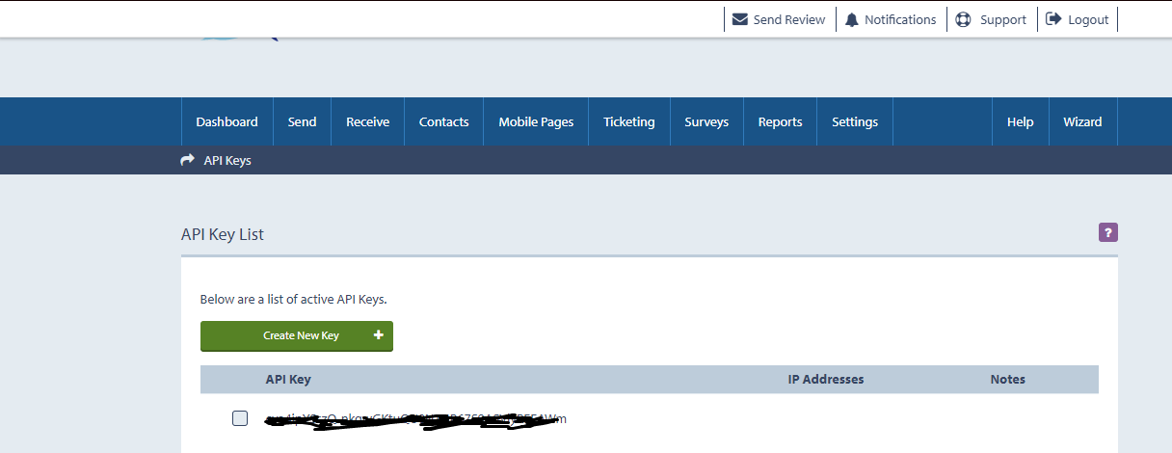

* Click Create new key and copy it in SendSMS Acivity